Overview:

An Event Management System provides campus event planners a flexible, fully integrated solution to simplify the event management process and keep your customers, faculty and students happy, while maintaining important reports and data for making real estate and future planning decisions.

Purpose:

An Event Management System (or Event Management Software) helps organizers plan, execute and report on events, driving success for their business

Empathy map:

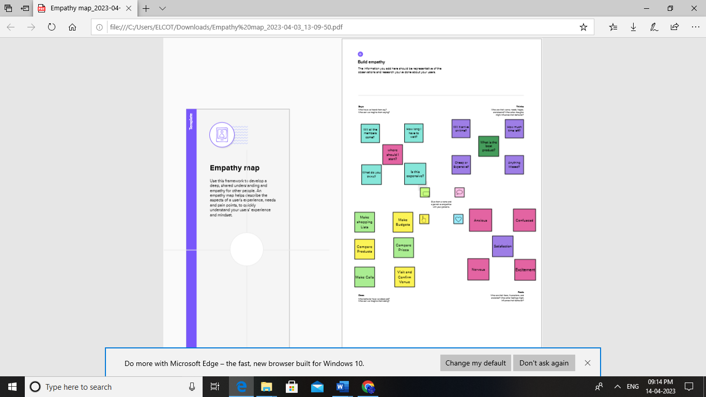 ***[1]***

Ideation & brainstorming map:

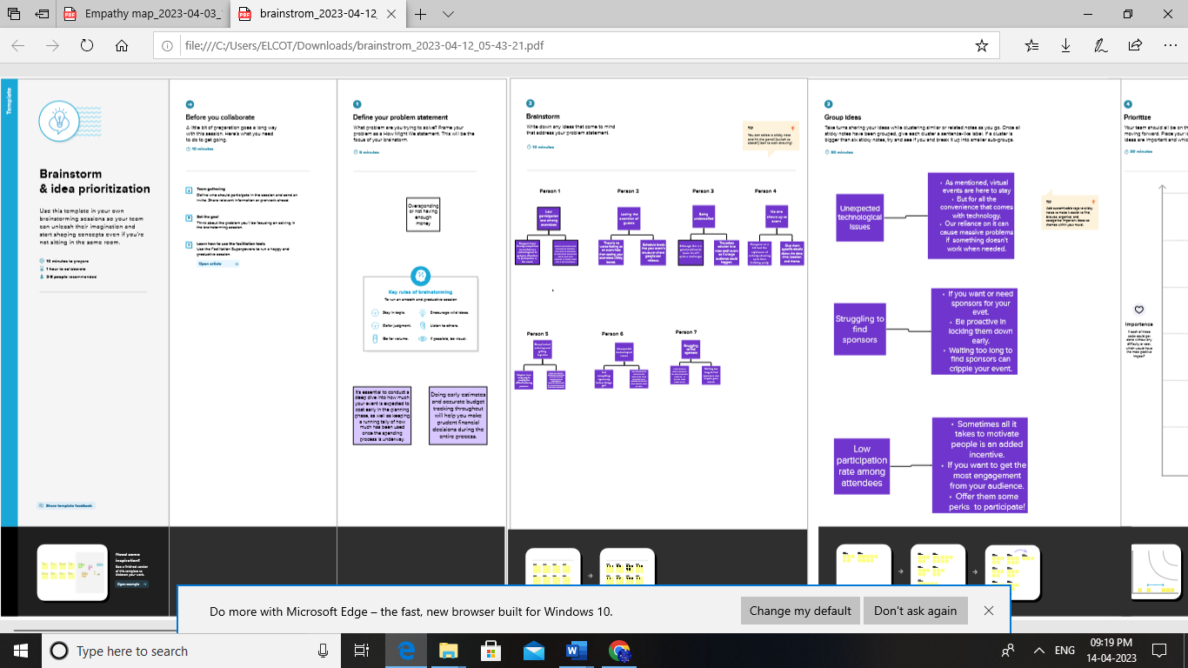

Data model:

|  |  |  |  |
| --- | --- | --- | --- |
| Object name | Fields in the object | | |
|  | Feilds | | Data type |
| Start date | Start date | | Date/Time |
| Service provider | Service provider | | Text |
| Phone | Phone | | Email |
| Id | Id | Auto number | |
| Event | Event | Text | |

Activity & screenshorts:

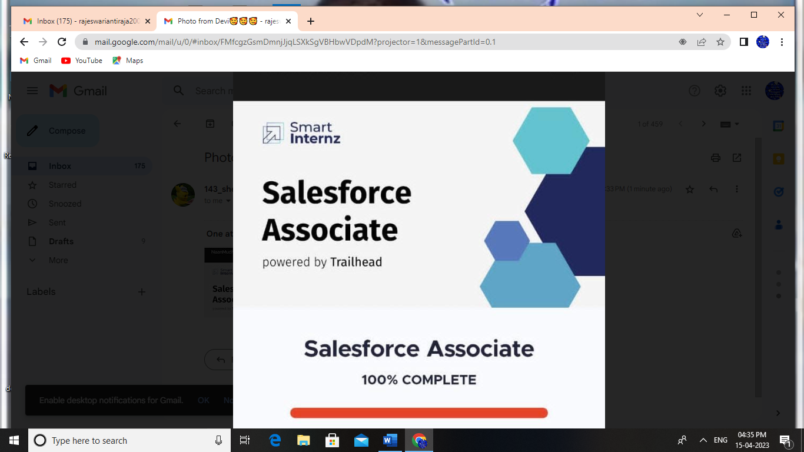

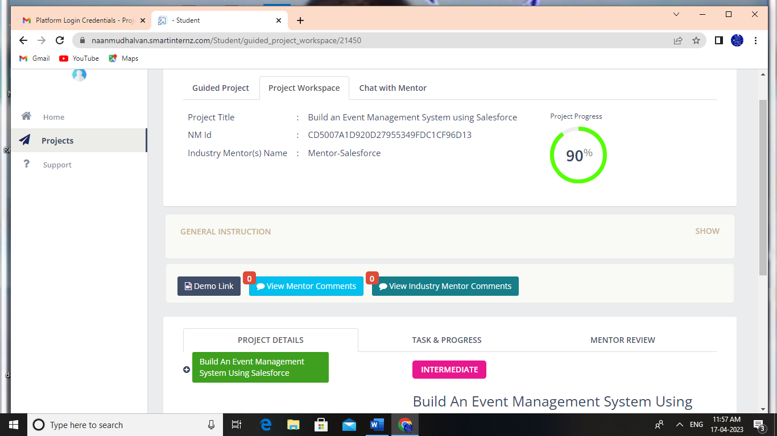

Trailhead Profile Public URL:

Team Lead -https://trailblazer.me/id/raji34

Team Member 1 - https://trailblazer.me/id/gayathiri04

Team Member 2 -https://trailblazer.me/id/rubina1762

Team Member 3 -https://trailblazer.me/id/devi43

Advantages &Disadvantage:

Advantages:

It goes without saying that organising an event, no matter the type of size, it is going to be stressful. There is so much to think about, to consider and to plan for, so, you may find that over time it all gets a little overwhelming

Despite the best planning, there are still things that can go wrong during an event. You may not be aware of the problems that can arise or the issues that can crop up. Which means that mistakes all too often happen, and you may not know how to fix them.

There are lots of legal requirements and guidelines that can go along with holding an event. You may be able to identify some of the things that you need to be aware of, but there is also a chance that you may miss some things.

Events by Knight design, plan, create and stage corporate events with a difference.  We know what works!  We provide a comprehensive start to finish event planning package for [Virtual](https://www.eventsbyknight.co.uk/blog/virtual-event-management) and Live events.

Disadvantage:

In terms of features, there’s not much to complain about when it comes to Salesforce. Just about every feature you could need from a CRM platform is there and you can add/delete features to suit your business needs

Where Salesforce let us down was in the pricing and usability department – and, unfortunately, the problems begin as soon as you start setting up the system. Unfortunately, the dealbreaker for us was the day-to-day use of the platform which manages to make even simple tasks frustratingly difficult to accomplish.

So that gives you an idea of what we liked and disliked about Salesforce so let’s take a look at the key features you can expect from Salesforce and how much it’s going to cost you.

Meanwhile, the customer support features are designed to help you keep your customers happy after the initial purchase and turn more of them into repeat buyers, positive reviews and brand loyalists.

Applications:

Extensibility of application development tools  
Businesses expect their development tools to be able to allow them to create unique custom applications. Often, in order for this to be possible, the tools themselves need to be customized.

 So the application development tools, beyond offering their own frameworks, need to be able to easily leverage open source tools such as AngularJS, Backbone, and Ember to allow for code-level customization and configuration.

Programming language compatibility  
Classically, enterprise tools have been tied to programming languages such as Java and .Net. Now there are newer breeds of application development frameworks and languages — such as the MEAN stack — that rely heavily on common languages such as JavaScript, Ruby, Python, and PHP.

In order to provide developers with the resources they need to be able to design applications, application development tools themselves need to be compatible with these languages. This allows businesses to create applications for a wide variety of platforms and projects.

Conclusion:

The best conclusions for a research paper summarize the paper without being redundant and express the impact of the research. As you watch this guide, don’t miss the pitfalls to avoid!

should be clear Writing a conclusion for your research paper can be difficult. Concluding paragraphs and sum up what you have presented in your research without sounding redundant.

An effective conclusion paragraph can also add impact to what you have presented in your paper.

Future Scope:

A new feature, which has in fact just been added but not yet used, allows the manager to specify certain module sessions as having a `Non-Registered' group. This contains all of the people who in fact are not registered to take that module, but who might suddenly decide to.

Another planned feature, which is related to the above, is a mechanism for informing each student, again by email, of the details which the system database has about him or her. This would be sent automatically as it changes, so the student can check the accuracy.

Smaller extensions to functionality include a desire to be able to record a query relating to a piece of work for an individual student. For example, when one suspects that the work was copied and the student is required to come and talk about it.

Perhaps the most complex intended extension is a provision for running unit-based laboratory courses. The idea here is that there would be a number of equally weighted units, or `milestones' making up the total work for one module.

1.